**Python Challenge 2**

The Pandas is a software library written for the [Python](https://en.wikipedia.org/wiki/Python_%28programming_language%29) programming language for data manipulation and analysis. In particular, it offers data structures and operations for manipulating numerical tables and [time series](https://en.wikipedia.org/wiki/Time_series). pandas is [free software](https://en.wikipedia.org/wiki/Free_software) released under the three-clause [BSD license](https://en.wikipedia.org/wiki/BSD_license). The name is derived from the term "panel data", an econometrics term for multidimensional structured data sets.

Using the pandas library and the csv for BabyNames. Please solve the following exercises.

1. Get the year, name, percent, sex of all boys

For eg. a subset of the data should look like the following

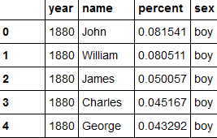

1. Index the data by unique identifier (year and name) and print the percent and sex
2. Print the names of all the boys born in year 1980
3. Plot the percentage of name Travis

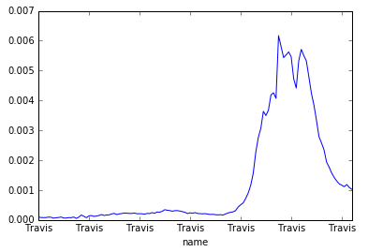

1. Get the names of all the girls and then plot the usage of name ‘Laura’ and ‘Rachel’ over the years on the same graph

